ENTER COMPLETE TITLE OF THE MS THESIS

TYPE STUDENT’S NAME

TYPE MAJOR ’S NAME

ENTER MONTH AND YEAR OF DEFENSE

KING FAHD UNIVERSITY OF PETROLEUM & MINERALS
DHAHRAN- 31261, SAUDI ARABIA
COLLEGE OF GRADUATE AND INTERDISCIPLINARY STUDIES
This thesis, written by TYPE STUDENT’S NAME under the direction of his thesis advisor and approved by his/her thesis committee, has been presented and accepted by the Dean, College of Graduate and Interdisciplinary Studies, in partial fulfillment of the requirements for the degree of MASTER OF SCIENCE IN BIOENGINEERING.

_______________________
Dr. TYPE NAME
Department Chairman

_______________________
Dr. Suliman S. Al-Homidan
Dean, College of Graduate and Interdisciplinary Studies

__________________
Date

________________________
Dr. TYPE NAME
(Advisor)

________________________
Dr. TYPE NAME
(Co-Advisor/Member)

________________________
Dr. TYPE NAME
(Member)

© Type Student’s Name
Type Year

Dedication

ACKNOWLEDGMENTS

Please remove the texts in red which is given only as a guide.

Its customary and good manners to say thank you.

Keep in mind that one has to use one’s own words when writing an acknowledgement. Plagiarism is unauthorized.

TABLE OF CONTENTS
Please remove the texts in red which is given only as a guide.
Instructions:
The table of contents is most easily created automatically with REFERENCE tools within WORD. Click on the following sequence: reference, index and tables, table of contents. The chapter titles and section headers should have been set to create a table of contents. It is important that the styles laid out in this template are used to maximize the benefits of the template and MS WORD options. The table of contents can be updated as you revise your thesis by using right mouse button and clicking on “update field.” With this approach, there is no need to copy and paste or retype your chapter and section titles.
Dedication iv
ACKNOWLEDGMENTS v
TABLE OF CONTENTS vi
LIST OF TABLES ix
LIST OF FIGURES x
LIST OF ABBREVIATIONS xi
ABSTRACT xii
1 CHAPTER 1 INTRODUCTION 1
1.1 Purpose (what the thesis aims to do) 1
1.2 Significance (why it matters) 2
1.3 Objectives (specific, numbered) 3
1.3.1 Sub-Section Title 3
1.3.2 Sub-Section Title 3
2 CHAPTER 2 LITERATURE REVIEW 5
2.1 Section Title 5
2.1.1 Sub-Section Title 5
2.1.2 Sub-Section Title 6
2.2 Section Title 6
2.2.1 Sub-Section Title 6
2.2.2 Sub-Section Title 6
3 CHAPTER 3 METHODOLOGY AND DESIGN 7
3.1 Section Title 8
3.1.1 Sub-Section Title 9
3.1.2 Sub-Section Title 9
3.2 Section Title 10
3.2.1 Sub-Section Title 10
3.2.2 Sub-Section Title 10
4 CHAPTER 4 RESULTS AND DISCUSSION 11
4.1 Section Title 11
4.1.1 Sub-Section Title 12
4.1.2 Sub-Section Title 13
4.2 Section Title 13
4.2.1 Sub-Section Title 13
4.2.2 Sub-Section Title 13
5 CHAPTER 5 CONCLUSION AND FUTURE WORK 15
5.1 CONCLUSION 16
5.2 FUTURE WORK 16
References 17
Vitae 18

LIST OF TABLES
Please remove the texts in red which is given only as a guide.
The list of tables is also easily created automatically with REFERENCE tools within WORD. Click on the following sequence: “REFERENCES, insert table of figures, (find “caption label” box set as – tables).” This can be updated as you revise your thesis by using right mouse button and clicking on “update field.” With this approach, there is no need to copy and paste or retype your chapter and section titles. You need to also use the table captions within the body of your thesis (see examples below). The insertion of table captions in this manner also helps because word automatically renumbers the tables within the text when you insert another table in the middle. There is no need for you to renumber the tables manually
Table 1 Measurements of Weather Conditions 3

LIST OF FIGURES
Please remove the texts in red which is given only as a guide.
The List of Figures is most easily created automatically with REFERENCE tools within WORD. Click on the following sequence: references, index table of figures, and Find “caption label” box set as – Figures. This can be updated as you revise your thesis by using right mouse button and clicking on “update field.” With this approach, there is no need to copy and paste or retype your chapter and section titles. You need to also use the figure captions within the body of your thesis (see examples below). The insertion of figure captions in this manner also helps because word automatically renumbers the tables within the text when you insert another table in the middle. There is no need for you to renumber the figures manually
Figure 1 TEM Image 3

LIST OF ABBREVIATIONS
Please remove the texts in red which is given only as a guide.
Enter the list of Acronyms / Abbreviations. Few examples are shown in the following

LED : Light Emitting Diode
MOS : Metal Oxide Semiconductor

ABSTRACT

Full Name | : | Type Student’s Full Name
Thesis Title | : | Type Complete Thesis Title
Major Field | : | Type Major
Date of Degree | : | Type Month and Year

Please remove the texts in red which is given only as a guide.
All the pages have been formatted in the accepted font and margin alignment. This is a simple MS thesis template that can be used for directly typing in your content. However, if you paste your text into the document, do so with caution as pasting could produce varying results. When directly typing into the title page and signature page, the appropriate information should be filled in the required fonts. When writing an abstract, bear in mind an abstract is a short descriptive summary of your thesis. The number of words accepted might vary e.g. 200-250 words. An MS thesis abstract need not exceed two pages. Abstracts are typically written last although they are the most important part of the thesis. They should have a little bit of everything: the background, the scope of your project, the purpose, findings and conclusions. An abstract is neither paragraphed nor cited. It should not be written as a literature review or a discussion of results. In a simplistic manner, your abstract, in a few words, should answer the questions: why should one care about your research; how did you get your results; what did you learn, find, create, invent; and finally, what do your results imply?

ملخص الرسالة

الاسم الكامل:

عنوان الرسالة:

التخصص:

تاريخ الدرجة العلمية:

CHAPTER 1
INTRODUCTION
Please remove the texts in red which is given only as a guide.
Typically, the first chapter is the Introduction. The main goal of your introduction is to identify a problem that is worthy of investigation. It must also provide some idea of your research goals and approach to research. Specific objectives can be introduced in the introduction chapter or they can be saved for later after you’ve provided additional background on the topic and state of the current research and its gaps. The Introductory chapter often concludes with a summary of the organization of the thesis, including identification of the general content of specific chapters and appendices.

Section Title
Please remove the texts in red which is given only as a guide.
The Section has the 2nd order heading. Enter subject matter for Sub-Section.
Ideally, chapter one defines the overall importance of the problem areas and provides an introduction into what you did, chapter two is why you did it in the context of what was previously known, three is how you did it, four is what you found and five is what it all means – putting the pieces together, (what’s your contribution to the research field).
It should be noted that the objectives of your research define the OUTCOME, i.e. what will be learned.
These define the required steps; they do not define the outcome so they are NOT objectives.
Some theses and dissertations can have some chapters written as manuscripts that can be submitted to peer-reviewed scientific research journals. In that scenario, the grad student should be the principal author of the pending articles. The thesis or dissertation that includes manuscripts as chapters are not exempt from writing an introduction, background/ literature review and overall conclusions and recommendations.

Section Title
Please remove the texts in red which is given only as a guide.
This template uses the MS WORD STYLES extensively to help keep your work in the proper format. These paragraphs use the “thesis-body text” style that is set for Times New Roman, 12-point font with double spaced lines and extra spacing between paragraphs (no need for hard carriage returns).

Section Title
Please remove the texts in red which is given only as a guide.
The chapters are divided into sections where each section is numbered as shown in the following. Each subsequent subsection will have a next order heading.
The Section has the 2nd order heading. Enter subject matter for Sub-Section.
The equations can be written using the equation editor built-in with the MS Word 2007
and above versions. The equations are numbered typically as shown below. The Equation numbering can follow different styles. Make sure you are aware of the style commonly used in your area. Sometimes un-numbered equations are used.
$z\left(t\right)=A_{c}[1+μx\left(t\right)]e^{jw_{c}t}$ (1.1)
$a\left(t\right)=A_{c}[1+μx\left(t\right)]$ (1.2)

Sub-Section Title
Please remove the texts in red which is given only as a guide.
There are also styles for headers, equations, captions and bulleted lists that you can choose to use. See examples throughout this template.

Sub-Section Title
Please remove the texts in red which is given only as a guide.
This is a sub-section and thus begins with the second order heading. Enter your text here.

CHAPTER 2
LITERATURE REVIEW
Please remove the texts in red which is given only as a guide.
The background and literature review section needs to provide sufficient fundamental background information about the subject to support your objectives, hypothesis (or research questions) and methods, and review the pertinent literature related to the specific problem / hypothesis you are addressing.
This page can be used as the sample for subsequent chapters. In the following the Sub-Sections are also enumerated.

Section Title

Please remove the texts in red which is given only as a guide. In the following it is shown how the equations may be inserted using the options in the MS Word. Use “Insert” option followed by “Equations” at the position where the equation needs to be inserted.
$y = \oint_{x=0}^{100}{e^{-x} dx}$ (2.1)

Sub-Section Title
Please remove the texts in red which is given only as a guide.
This page can be used as the sample for subsequent chapters. In the following the Sub-Sections are also enumerated.

Sub-Section Title
This page can be used as the sample for subsequent chapters. In the following the Sub-Sections are also enumerated.

Section Title

Sub-Section Title
This page can be used as the sample for subsequent chapters. In the following the Sub-Sections are also enumerated.

Sub-Section Title
This page can be used as the sample for subsequent chapters. In the following the Sub-Sections are also enumerated.

CHAPTER 3
METHODOLOGY AND DESIGN
Please remove the text in red, which is provided only as a guide.
The Methodology and Research Design chapter should clearly describe how the study was planned and conducted. The division of material into sections or chapters should be logical and appropriate to the nature of the research.
Ensure that the overall research design is clearly stated and justified. Explain why the chosen approach (e.g., experimental, analytical, computational, qualitative, quantitative, or mixed methods) is appropriate for addressing the research questions or objectives.
Describe in sufficient detail the materials, data sources, participants (if applicable), instruments, and procedures used in the study so that the work can be understood and, where appropriate, replicated. Clearly state what variables or parameters were controlled, measured, or manipulated, and explain how data were collected.
If models, algorithms, simulations, or experimental setups are used, provide a clear description of their development, assumptions, and limitations. Any software, hardware, or specialized tools should be identified.
Explain the data analysis methods in detail, including any preprocessing steps and the statistical or analytical techniques employed. Justify the choice of methods and statistical tests, and state any assumptions made.
Finally, discuss any ethical considerations, constraints, or limitations related to the methodology, and explain how these were addressed during the study.

Section Title
Please remove the texts in red which is given only as a guide.
Following is a figure inserted to show how the Figures are captioned and used. Use the “Insert” option to insert a figure or a plot at the position you want to insert the image/plot. Right click the image/plot and use the “Insert Caption” to insert the caption on the figure/plot. The Caption must contain the index of the figure/plot and a concise description. Each figure/plot should be placed at the center of a new page.
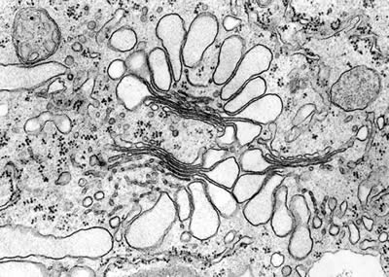
Figure 1 TEM Image

Sub-Section Title
Please remove the texts in red which is given only as a guide.
This page can be used as the sample for subsequent chapters. In the following the Sub-Sections are also enumerated.

Sub-Section Title
This page can be used as the sample for subsequent chapters. In the following the Sub-Sections are also enumerated.

Section Title

Sub-Section Title
This page can be used as the sample for subsequent chapters. In the following the Sub-Sections are also enumerated.
In the following a Table is shown. Use the “Insert” option to insert a Table by and select appropriate number of rows and columns.
Table 1 Measurements of Weather Conditions (1)
Date | Temperature (maximum) | Temperature (minimum) | Humidity (maximum) | Humidity (minimum) | Wind Speed (average)

Sub-Section Title

This page can be used as the sample for subsequent chapters. In the following the Sub-Sections are also enumerated.

CHAPTER 4
RESULTS AND DISCUSSION
Please remove the texts in red which is given only as a guide.
The results and discussion are very often combined in theses. The division of Results and Discussion material into chapters is usually best done according to subject matter.
Make sure that you have described the conditions which obtained for each set of results. What was held constant? What were the other relevant parameters? Make sure too that you have used appropriate statistical analyses. Use appropriate statistical tests.
In most cases, your results need discussion. What do they mean? How do they fit into the existing body of knowledge? Are they consistent with current theories? Do they give new insights? Do they suggest new theories or mechanisms?
Try to distance yourself from your usual perspective and look at your work. Do not just ask yourself what it means in terms of the orthodoxy of your own research group, but also how other people in the field might see it. Does it have any implications that do not relate to the questions that you set out to answer?

Section Title
Please remove the texts in red which is given only as a guide.
Following is a figure inserted to show how the Figures are captioned and used. Use the “Insert” option to insert a figure or a plot at the position you want to insert the image/plot. Right click the image/plot and use the “Insert Caption” to insert the caption on the figure/plot. The Caption must contain the index of the figure/plot and a concise description. Each figure/plot should be placed at the center of a new page.
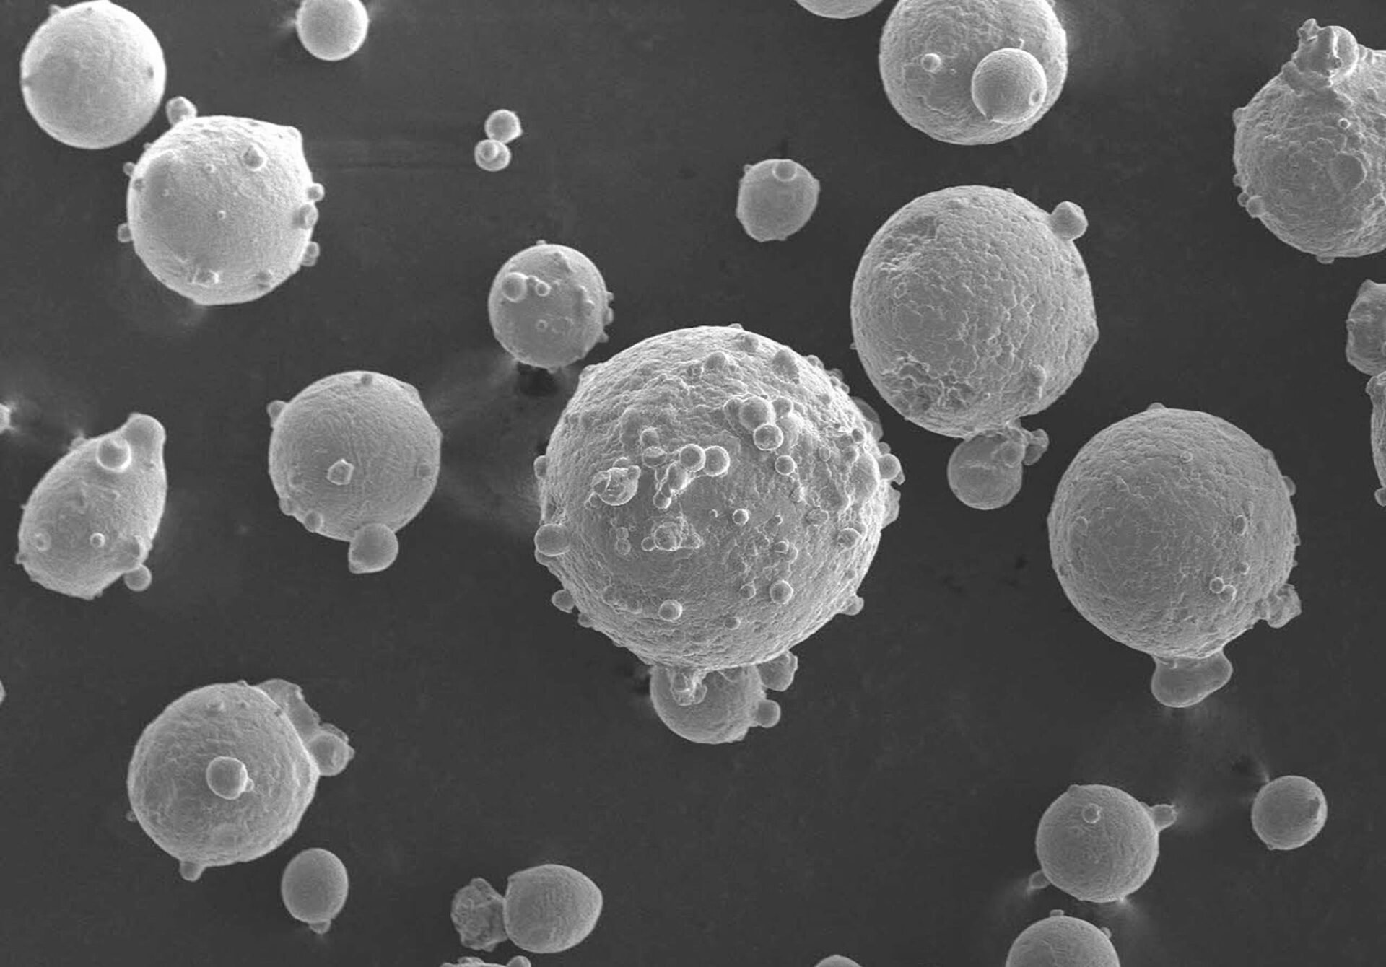
Figure 2 SEM Image

Sub-Section Title
Please remove the texts in red which is given only as a guide.
This page can be used as the sample for subsequent chapters. In the following the Sub-Sections are also enumerated.

Sub-Section Title
This page can be used as the sample for subsequent chapters. In the following the Sub-Sections are also enumerated

Section Title

Sub-Section Title
This page can be used as the sample for subsequent chapters. In the following the Sub-Sections are also enumerated.
In the following a Table is shown. Use the “Insert” option to insert a Table by and select appropriate number of rows and columns.
Table 2 Measurements of Weather Conditions (2)
Date | Temperature (maximum) | Temperature (minimum) | Humidity (maximum) | Humidity (minimum) | Wind Speed (average)

Sub-Section Title

This page can be used as the sample for subsequent chapters. In the following the Sub-Sections are also enumerated.

CHAPTER 5
CONCLUSION AND FUTURE WORK
Please remove the text in red, which is provided only as a guide.
The Conclusion and Future Work section should summarize the overall outcomes of the study and clearly state the main contributions of the thesis. The conclusion should not introduce new results, data, or analysis, but should synthesize the key findings presented in earlier chapters.
Clearly restate the research objectives or questions and explain how they have been addressed by the work. Highlight the most important results and discuss their significance in the context of the field.
Discuss the limitations of the study and how they may have affected the results or interpretations. This discussion should be balanced and objective.
The Future Work section should identify potential extensions and directions for further research that logically arise from the current study. These may include improvements to the methodology, additional experiments or analyses, alternative approaches, or applications of the results to new problems or contexts.
Future work should be specific and realistic, clearly explaining how it builds on the findings of the thesis rather than being a general list of ideas.

CONCLUSION

FUTURE WORK

References
Please remove the texts in red which is given only as a guide. The following is an example of writing the references which have been referenced to in the Thesis.
[1] Shannon, C.E.; "Communication in the Presence of Noise," Proceedings of the IRE, vol.37, no.1, pp. 10- 21, Jan. 1949
[2] R. F. Harrington, “Effect of antenna size on gain, bandwidth, and efficiency,” J. Res. Nat. Bureau Standards, vol. 64D, pp. 1–12, Jan.-Feb. 1960
[3] Gardner, W.; "Spectral Correlation of Modulated Signals: Part I--Analog Modulation," Communications, IEEE Transactions on, vol.35, no.6, pp. 584- 594, Jun 1987
[4] S. G. Wilson, Digital Modulation and Coding. Englewood Cliffs, NJ: Prentice-Hall, 1996.
[5] Murota, K.; Hirade, K.; "GMSK Modulation for Digital Mobile Radio Telephony," Communications, IEEE Transactions on, vol.29, no.7, pp. 1044- 1050, Jul 1981

Vitae
Prepare your vitae in such a way that anyone who wants to cite your work should know you and your academic research & work clearly and properly. Specifically, mention (if any) paper presented in any seminar or published in a reputable journal.

Name :
Nationality :
Date of Birth :
Email : use NON-KFUPM email
Address :
Academic Background :

